## 

## **IMPORTANT POINTS TO REMEMBER**

**35% of the overall process is learnt in the sessions** (6 Week Job Ready Programme)

**65% of the overall process is learnt in the internship** (3+ month internship and supported   
 right through until you secure an IT Job)

**WEEK 5 of your Job Ready Programme you will receive an email from the MVP Studio Team about your NEXT STEPS for the INTERNSHIP**

**ZOOM MEETING INSTRUCTIONS**

1) Download and run the .exe file from Zoom.

2) Enter your name (for display on screen).

3) If you can't hear the tutor, please click the Join Audio button.

**Session Recordings:** All sessions are recorded and will be available to you on the calendar the next day for review. They will be available for 3 months.

**IMPORTANT - MEETING CODE:** At the end of each session, a **MEETING CODE** will be given to you in the Slack Channel by your tutor. Every meeting has a different code. ***Please copy that CODE and PASTE it into the MEETING ATTENDANCE (see screenshot below and Onboarding Video) and submit.*** The system will allocate 5 IC points to you for each meeting code attendance submitted.

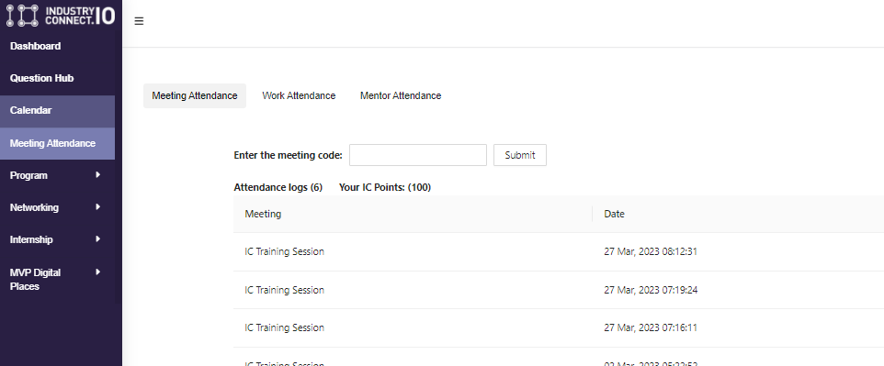

**Materials**

You can access the course slides under the Programme Menu.

(<http://www.industryconnect.io/Course/Home/MyProgram>)

Source code and extra materials for the topics will be shared during or after the classes.

**Tools**

Please install all the tools below before the class.

1. Visual Studio - you will use this to write C# code and build applications.   
   Make sure you install the **'.NET Desktop Development'** and **'**[**ASP.NET**](http://asp.net) **and web development'** workloads.
   1. <https://www.visualstudio.com/vs/community/>
2. SQL Server - you will use this to create the database. The '**Developer**' edition is recommended.
   1. <https://www.microsoft.com/en-us/sql-server/sql-server-editions-express>

**Tutor Details**

Please contact:

* [sd@industryconnect.org](mailto:sd.nz@industryconnect.org)